Source ID - 915374765

Source Title - Plant Science Today

Agreement URL - http://horizonepublishing.com/journals/index.php/PST/index

Click Current from the Articles Dropdown.

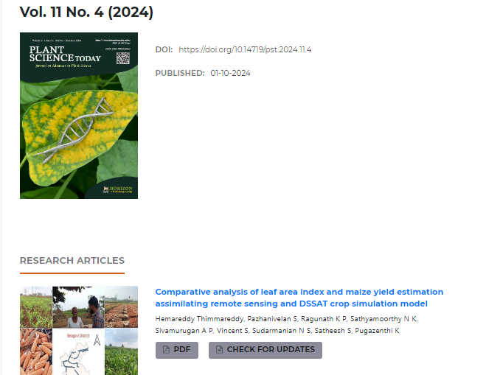

Click to capture meta data

Volume

Issue

Year

Article title

PDF

DOI